**Migrate an EC2 Instance to Another Region (Mumbai to Singapore)**

In this document, I will outline the step-by-step process I followed to migrate an Amazon EC2 instance from the **Mumbai (ap-south-1)** region to the **Singapore (ap-southeast-1)** region. This migration was done using an Amazon Machine Image (AMI) and launching a new instance in the target region.

**Step 1: Create an AMI of the Existing EC2 Instance**

1. Navigate to the **AWS EC2 Console** in the Mumbai region.
2. Select the instance to migrate.
3. Click on **Actions > Image and templates > Create image**.
4. Provide a suitable name and description for the AMI.
5. Click **Create Image** and wait for the AMI creation to complete.

**Step 2: Copy the AMI to the Singapore Region**

1. Go to **EC2 Dashboard > Images > AMIs**.
2. Select the newly created AMI.
3. Click on **Actions > Copy AMI**.
4. Choose **Singapore (ap-southeast-1)** as the destination region.
5. Click **Copy AMI** and wait for the process to complete.

**Step 3: Launch a New Instance in the Singapore Region**

1. Switch to the **Singapore (ap-southeast-1)** region in the AWS console.
2. Navigate to **EC2 Dashboard > AMIs**.
3. Select the copied AMI and click **Launch instance from AMI**.
4. Choose an instance type (**t2.micro** for free tier eligibility).
5. Configure network settings (VPC, subnet, security group as per requirement).
6. **Create a new key pair** and download it.
7. Click **Launch Instance**.

**Conclusion**

The EC2 instance was successfully migrated from **Mumbai (ap-south-1)** to **Singapore (ap-southeast-1)**. This method ensures minimal downtime and allows for easy migration using AMIs. The new instance is now fully operational in the Singapore region.

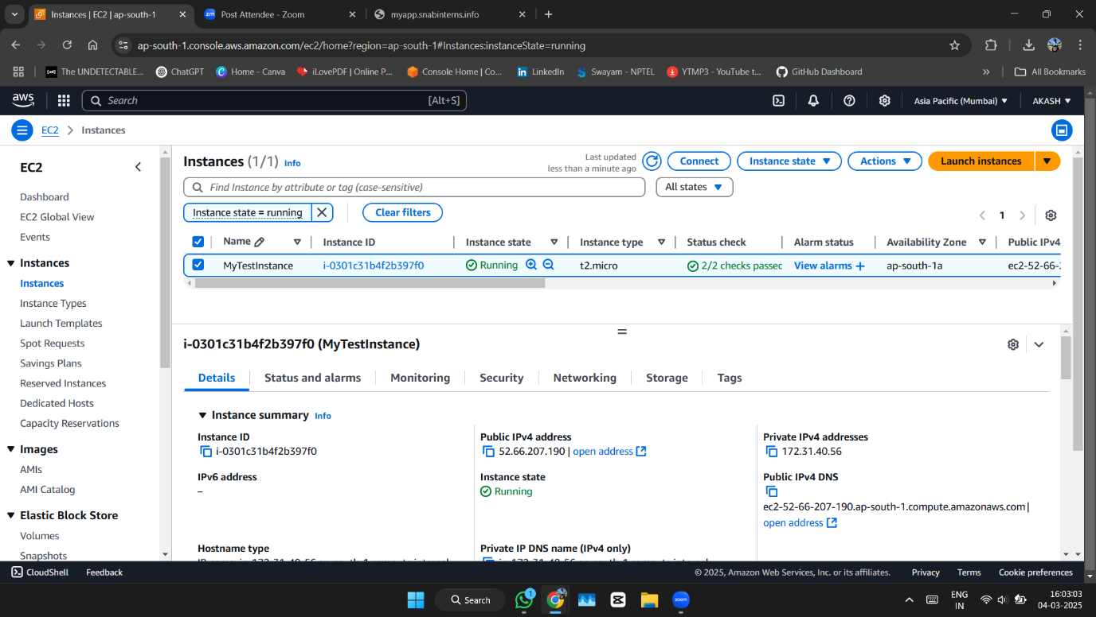

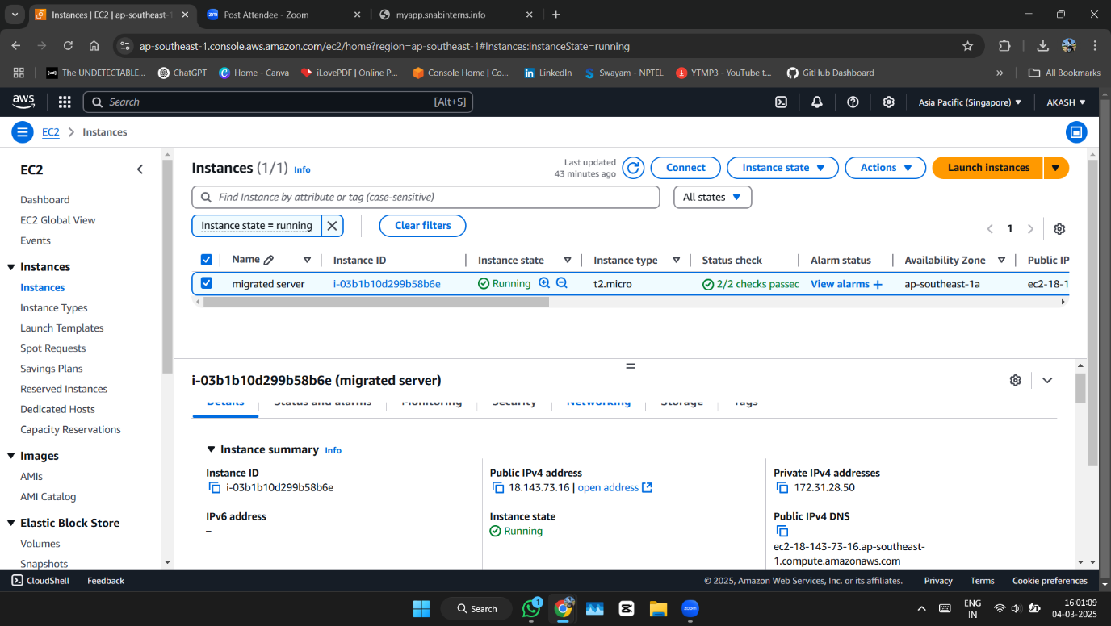

**2.Enabling AWS Systems Manager (SSM) for EC2**

**Objective**

To install the AWS Systems Manager (SSM) agent on an EC2 instance and configure it for remote access without using SSH keys.

**Step 1: Verify EC2 Instance Details**

1. Open the **AWS Management Console** and navigate to **EC2 Dashboard**.
2. Click on **Instances** from the left-side menu.
3. Select the EC2 instance where you want to enable SSM.
4. Go to the **Details** tab and check the **IAM Role** assigned to the instance.
5. If no IAM role is attached, proceed to the next step to create and attach the required role.

**Step 2: Attach an IAM Role with SSM Permissions**

1. Go to the **IAM Console** → Click **Roles** → Click **Create Role**.
2. Select **AWS Service** → Choose **EC2** → Click **Next**.
3. Search for the policy **AmazonSSMManagedInstanceCore** and attach it.
4. Name the role (e.g., **SSM-EC2-Role**) and create it.
5. Go back to the EC2 instance, select it, click **Actions** → **Security** → **Modify IAM Role**.
6. Attach the newly created **SSM-EC2-Role** to the instance.

**Step 3: Install and Start SSM Agent (If Not Installed)**

📌 **Ubuntu/Debian:**

sudo snap install amazon-ssm-agent --classic

sudo systemctl enable amazon-ssm-agent

sudo systemctl start amazon-ssm-agent

**Step 4: Verify SSM Agent Status**

1. Run the following command to check if the agent is running:
2. sudo systemctl status amazon-ssm-agent
3. If the agent is running, you should see **Active (Running)** in the output.

**Step 5: Confirm Instance is Managed by AWS Systems Manager**

1. Navigate to **AWS Systems Manager Console**.
2. Click on **Explore nodes**
3. Check if the EC2 instance appears in the managed instances list.
   * ✅ If listed, the setup is successful.
   * ❌ If not listed, verify IAM permissions and SSM agent status.

**Step 6: Connect to EC2 Using AWS Systems Manager**

1. Go to **AWS Systems Manager** → Click **Session Manager**.
2. Click **Start Session**.
3. Select the EC2 instance and click **Start Session**.
4. I have terminal access to my instance without using SSH keys!

**Conclusion**

By following these steps, I successfully installed and configured the AWS Systems Manager (SSM) agent for my EC2 instance. Now, I can securely manage the instance without SSH keys, making remote administration more secure and convenient. ✅

